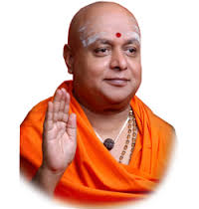 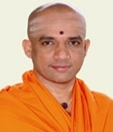

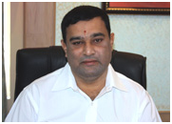 

**ACKNOWLEDGEMENT**

I would like to express my profound thanks to His Divine Soul **Padmabhushan Jagadguru Sri Sri Sri Dr. Balagangadharanatha Maha Swamiji** and His Holiness **Jagadguru Sri Sri Sri Dr. Nirmalanandanatha Maha Swamiji** for providing me an opportunity to pursue my academics in this esteemed institution.

I would also like to express my profound thanks to **Reverend Sri Sri Prakashnath Swamiji**, Managing Director, SJB Institute of Technology, for his continuous support in providing amenities to carry out this mini project in this admired institution.

I express my gratitude to **Dr. Puttaraju**, Principal, SJB Institute of Technology, for providing an excellent facilities and academic ambience; which have helped me in satisfactorily completion of mini project work.

I extend my sincere thanks to **Dr. Mohan H S**, Head of the Department, Information Science and Engineering; for providing an invaluable support throughout the period of mini project work.

I wish to express heartfelt gratitude to my guide**, Chetan R**, for his valuable guidance, suggestions and cheerful encouragement during the entire period of this work.

I express my truthful thanks to **Kiran Kumar V.,** Mini Project Coordinator, Dept. ISE for his valuable support.

Finally, I take this opportunity to extend my earnest gratitude and respect to my parents, Teaching & Non-teaching staffs of the department, the library staff and all my friends, who have directly or indirectly supported me during the period of this mini project work.

Regards,

Prajwal V Bharadwaj (1JB15IS075)